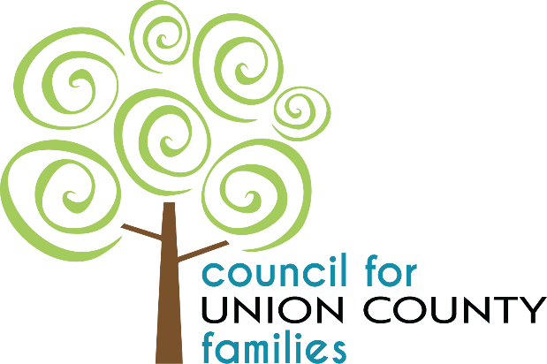
CUCF’s vision is to become a council that efficiently works together to serve the Union County community – keeping families safe, strong, and intact.

CUCF December Meeting Minutes
December 18th, 2024, 2:00pm-3:00pm
Voting Members Present: Kathryn Tummino (Secretary - MHRBUC), Lori Poling (Parent Rep), Jennifer Gross (Parent Rep), Adam Negley (MHRB), Jamie Harris (Leads Head Start/EHS), Jerome Shapiro (Parent Rep), Officer Amy Finley (MPD), Kara Brown (UCBDD)
Mandated Members on Zoom (voting not allowed): Marcie Barhorst (Bridges Community Action), Patrice JPO Edwards (DYS
Voting Members Absent: Sue Ware (Chair, Human Services), Jason Orcena (Vice Chair, Health Dept.), Justin Ufferman (North Union Local Schools), Dave Lawrence (Commissioner), Diane Allen (MEVSD)
Other Attendees: Vanessa Humphrey (Director, CUCF), Andy Johnson (Hope Center), Jennifer Rigano (CUCF), Wren Hawkins (CUCF), Halle DuMoulin-Camella (MHRBUC), LaToya McGary (Harbor), Paul Garrett (Harbor), Anastasia Lacure-Willey (Harbor), Melinda Moreno (Action for Children, Triple P), Lindsay Altizer (MHRBUC)
Zoom Guests: Katie Bock (BBBS), Nicole Neumeier (CUCF), Jackie Fewings (WIC), Angie Greene (Tolles), Joe Newell (Fairbanks), Brandi Hibbs (United Way), Kasey Bisch (OhioGuidestone), Melissa Ebling (Maryhaven), Frank Drago (Aetna), Holly Novak (NAMI)

- Call to Order – Tummino
- CUCF Vision Statement
- Welcome Marcie Barhorst from Bridges, replacing Bryant Dill

- November 2024 Meeting Minutes – Tummino: Motion Required
  - Tummino asked for a motion to approve the October Meeting Minutes.
    - Motion to approve by Jerome Shapiro, Second by Jennifer Gross. No discussion. All in favor. Motion carried.

- Financials
- Approval of November Financial Report – Humphrey: Motion Required
- Vanessa presented November Financial Report found in board packet; Lindsay Altizer (MHRBUC) provided additional information on budget vs. actual spending and that QuickBooks and Munis are in balance with the County.
- Tummino asked for a motion to approve the November Financial Report.
  - Motion to approve by Kara Brown; Second by Jennifer Gross. No discussion. All in favor. Motion carried.

- New Business
- OFCF announced MSY Incentive Funds to support Shared Plans – Humphrey
- Vanessa shared details on how CUCF would plan to spend MSY Incentive Funds to support the CUCF Shared Plan with focus on increasing provider knowledge on services available in Union County through a No Wrong Door event and quarterly updates and increasing parent education and usage or prevention services. Application due January 7th. If all 88 counties applied and were awarded, CUCF would receive $16,402.
- Jerome shared his input on using MSY Incentive Funds to provide low to no-cost movie screening opportunities to families in Union County to promote outreach.
  - Vanessa said that there is a list of approved Shared Priorities from the state that CUCF must choose from and that this would not fit into one of the Shared Priorities.
- Nominating and approval of 2025 CUCF Officers – Tummino: Motion Required
- Tummino asked for nominations.
  - Nominations for Chair for CUCF for calendar year 2025
    - Vanessa nominates Adam Negley
      - Jerome asked if this is a conflict of interest since MHRBUC is the administrative agent for CUCF. Vanessa shared that there is nothing in ORC that prevents the administrative agent from being the chair and many other county FCFCs currently have a representative from their administrative agent as their chair. Sue and Jason also shared that when other agencies were administrative agents, representatives from their agency held the position of chair.
      - Motion to approve by Amy Findley, Second by Jerome Shapiro.
  - Nominations for Vice Chair for CUCF for calendar year 2025.
    - Vanessa nominates Jason Orcena
      - Vanessa noted that she has already talked to Jason and his only stipulation is that his chair is only allowed 2 absences.
      - Motion to approve by Kara Brown, Second by Jamie Harris.
  - Nominations for Secretary
    - Vanessa nominates Kathryn Tummino
      - Motion to approve by Jennifer Gross, Second by Lori Poling
- Tummino asked for a motion to approve the officer slate for 2025: Chair – Adam Negley; Vice Chair – Jason Orcena; Secretary – Kathryn Tummino
  - Motion to approve by Kara Brown. Second by Jerome Shapiro. All in favor. No discussion. Motion carried.

- Old Business
- Approval of Service Coordination Mechanism – Humphrey: Motion Required
- Vanessa reviewed Service Coordination Mechanism, parent representatives Lori Poling and Jennifer Gross gave feedback, and was sent to board at the beginning of the month for review.
  - Jerome asked if this would be given to parents; Vanessa shared that this document is available to parents at any time, but they provide rack cards and website information to parents.
    - Jerome shared that this document is very technical, and he does not see this going to families unless requested.
    - Vanessa shared that this document goes to community partners, like schools, and that this information must be publicly available.
- Tummino asked for a motion to approve the Service Coordination Mechanism.
  - Motion to approve by Lori Poling. Second by Jamie Harris. No discussion. All in favor, Jerome Shapiro abstained. Motion carried.

- Union County Report
- CUCF Director’s Report – Humphrey
  - Vanessa highlighted November caseloads, provided an update on SFCS funding, and Operation Warm coat delivery to LEADS HeadStart and Hope Center.
- OHR Report – LaToya McGary & Frank Drago
  - LaToya update:
    - November Referrals: 8 total; 2 from Aetna and 6 from Member Alignment Files
  - Frank update:
    - Total enrolled in Union County = 127 youth
    - Tier 1 = 90 youth; Tier 2 = 16 youth; Tier 3 = 21 youth

- OhioRISE Wavier Process – Harbor (Anastasia Lacure-Willey & Paul Garrett)
  - Anastasia provided background information on OhioRISE and the services that are offered.
  - Waiver Process
    - Need for out of home respite, secondary flex funds, or transitional flex funds
      - Every youth in OhioRISE has access to behavioral health respite for 51 session of up to 3 hours per day
        - Out of Home Respite: This is for youth who need overnight, out of home respite. This need is identified by the CANS.
        - Secondary Flex Funds: This is for youth who’ve already utilized the $1,500 Primary Flex Funds that all OhioRISE youth have access to. These funds can be used for services and items that support the youth’s plan of care. Secondary Flex Funds can be up to $3,000. Examples: YMCA passes, specialized watches for youth with escape behaviors, etc.
        - Transitional Services and Supports – This provides support for youth in transition with behavioral health challenges to assist the family understand, mitigate, and provide connections to long term services.
    - A full diagnostic assessment completed by a licensed professional must be completed prior to the wavier process being initiated. A CANS is then completed and must indicate a youth is eligible for Tier 2 or 3. Noted that once the CANS is complete, Harbor must step out and allow the family to apply for Medicaid on their own. Once enrolled in Medicaid, Harbor is notified through Member Alignment Files.
    - Paul explained that the OhioRISE waiver is “access to Medicaid funding for 3 specific services”.
    - Contact the Senior Leadership Team via email at CMEDirector@Harbor.org

- Adjourn
  - Motion to adjourn by Kara Brown, second by Jamie Harris. All in favor. No discussion. Motion carried.

Next Meeting: Vision Meeting
Wednesday, January 15th, 2025 from 2:00-4:00pm
Conference Room- Mental Health and Recovery Board of Union County
131 N Main St., Marysville OH 43040

